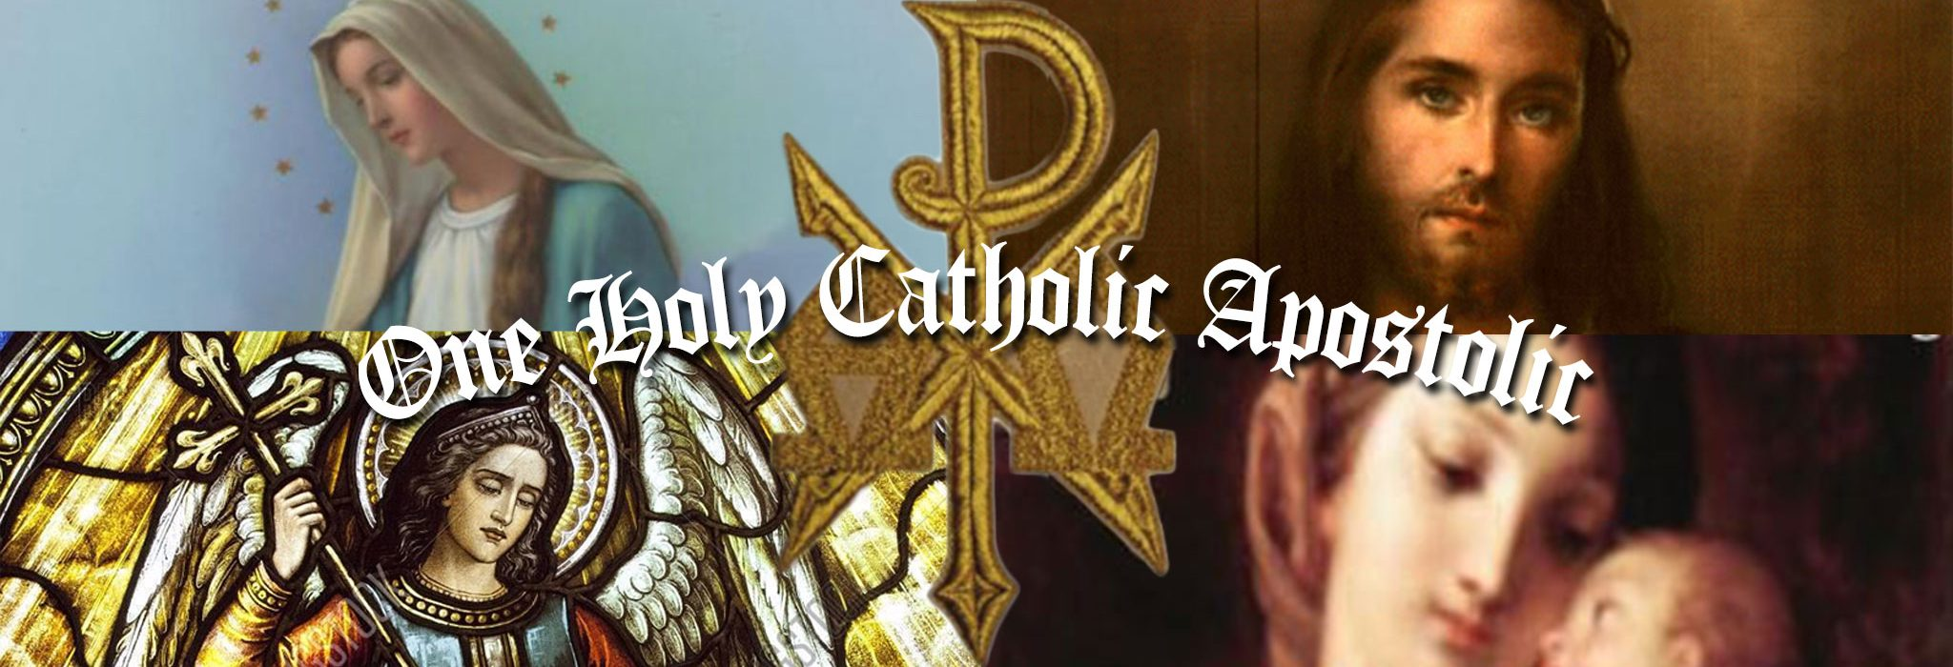Champaign County Region of Parishes Registration Form
In order for the parish to have the most complete and up to date information, someone from the parish office may contact you at a later date for more information.
Please Print Legibly
Parish Where You’re Registering: St. Mary __________ St. Michael __________ Envelope#___________
Sacred Heart __________ Immaculate Conception__________ (for office use)
Family Name: _____________________________________________________________________________________________
Home Address: ____________________________________________________________________________________________
City: ____________________________________________________ State: ________________ ZIP: _______________________
Home Phone: _____________________________________ Check Here if Unlisted: _______
Cell Phone: _______________________________________ E-mail:_________________________________________________
Family Members: (First, Middle, and Last Names)
Head of Household: ________________________________________________________________________________________
Date of Birth: ___________________________ Catholic: _________________________ Non-Catholic:______________________
Spouse: __________________________________________________________________________________________________
Maiden Name: ________________________________________
Date of Birth: ___________________________ Catholic: _________________________ Non-Catholic:______________________
Marital Status: Single:________ Marriage recognized by Church:________ Widow(er):________
Married out of Church:________ Separated:________ Divorced:________
Minor Children Residing at Home:
Full Name Date of Birth: Catholic Y or N
______________________________________ ____________________________ ______________________
______________________________________ ____________________________ ______________________
______________________________________ ____________________________ ______________________
Information continued on the back of this sheet
Minor Children Residing at Home:
Full Name Date of Birth: Catholic Y or N
______________________________________ ____________________________ ______________________
______________________________________ ____________________________ ______________________
______________________________________ ____________________________ ______________________
______________________________________ ____________________________ ______________________
______________________________________ ____________________________ ______________________
______________________________________ ____________________________ ______________________
______________________________________ ____________________________ ______________________

Please check the areas of service for which you would like additional information, or in which you would like to participate.

First Name Service Area/Activity First Name Service Area/Activity

Service Worship
______________Welcoming New Members ______________Choir
______________Greeting Card Ministry ______________Youth Choir
______________Bereavement Luncheons ______________Lector (reader)
______________Food Ministry ______________Minister of Holy Communion
______________Prayer Chain ______________Usher or Greeter
______________Medical Equipment Ministry (Padre Pio) ______________Take Communion to Homebound
______________Other ______________Sacristan
______________Server

Evangelization
______________Evangelism Committee (Kolbe Commission) Fellowship
______________Silent Retreat (Encounter With Silence) ______________Women’s Group
______________ALPHA Program ______________Men’s Group
______________Other ______________Youth Group
______________Family Nights
Learning ______________Knights of Columbus
______________Rite of Christian Initiation ______________Scouting
______________Bible Study ______________Coffee & Donuts/Brunch/Breakfast
______________Financial Peace University ______________God Moments
______________Parish School of Religion/CCD/PSR ______________Book Discussion Group
______________Adult Faith Formation Committee ______________Other
______________Other

Administration
______________Parish Council ______________Office Help
______________Holiday Decorating ______________Buildings and Grounds Committee
______________Grounds Care ______________Being a Group Leader
______________Interior Care ______________Making Phone Calls
______________Communication ______________Teaching/Helping with Parish School
______________Fund Raising Ideas of Religion
______________Other Types of Volunteer Opportunities That Arise

