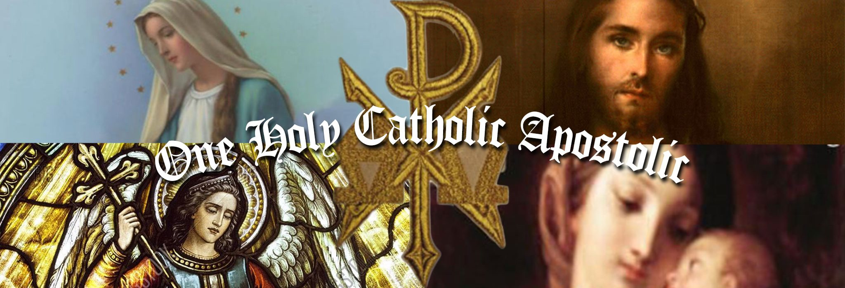Champaign County Parishes
Rite of Christian Initiation for Adults (RCIA) Registration Form

Please Print Legibly
Name: ___________________________________________________________________________________________________
Home Address: ____________________________________________________________________________________________
City: ____________________________________________________ State: ________________ ZIP: _______________________
Home Phone: _____________________________________ Check Here if Unlisted: _______
Cell Phone: _______________________________________ E-mail:_________________________________________________
Have you been Baptized: Yes__________ No__________ Date of Baptism________________________________
Name of Church of Baptism:__________________________________________________________________________________
Address of Church of Baptism:________________________________________________________________________________
Present Church Membership or Attendance:_____________________________________________________________________
Please tell us how you became interested in the Catholic Church:

Current Marital Status: Married in the Catholic Church:________ Married outside of Catholic Church:________
Widow(er):________ Separated:________ Divorced:________
Name of Spouse:___________________________________________________________________________________________
Please list any previous marriages on the back of this sheet

Record of previous marriages

Name of Previous Spouse:___________________________________________________________________________________
Married in the Catholic Church:________ Married outside of Catholic Church:________
Widow(er):________ Separated:________ Divorced:________
Name of Previous Spouse:___________________________________________________________________________________
Married in the Catholic Church:________ Married outside of Catholic Church:________
Widow(er):________ Separated:________ Divorced:________
Name of Previous Spouse:___________________________________________________________________________________
Married in the Catholic Church:________ Married outside of Catholic Church:________
Widow(er):________ Separated:________ Divorced:________

Please complete this form and return it to:
St. Mary Church
231 Washington Avenue
Urbana, OH 43078

If you have any questions you can reach us at 937-653-1375.

Once we have received your completed form, our RCIA Instructor will be in touch with you. Thank you!

